**How to set up the project?**

Import the project with all the package structure.

Make sure your JAVA _HOME and ANT_HOME, PATH are set properly.

Include the Jfree, Jframe and apache POI jar files and build them.

**How to run the Jfree for identifying frauds**

PassOn the fields that you want to evaluate your graph as the parameters in the highlighted snippet

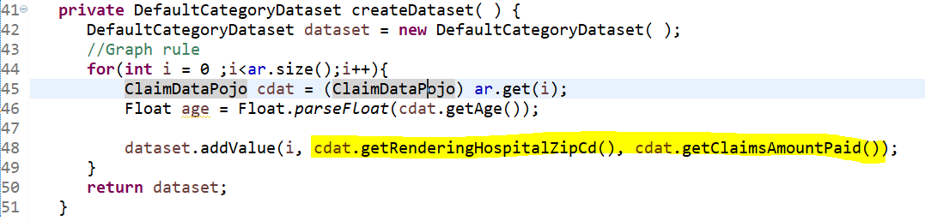

Save the file and run the application as java application.

You could see the windows Jframe popup with the complete claim data set

**How to see the screens**

The graph is popped up as a Jframe and would not require any additional process.

The Input data UI however needs to be launched by running the **index.html**.